# Enrollment

1. There is not a validation check in the Logic Provider for the Sponsor / Enroller information – is this on purpose? Do we want a simple check in JavaScript or within the Logic Provider itself to redirect them back to the page if this is null?
2. The Enrollment Configuration, Shopping and Enrollee Information forms do not differentiate between PC and Distributor and presents the same Enrollment fee and shopping requirements - logic needs to be added to Views, Logic Provider, and Property Bag to achieve this
3. There are no validation messages displaying on the Enrollment Shopping Pages if a step is missed and the Logic Provider returns the viewer to the page – there is no toastr error message being fed in as part of the JavaScript validation
4. Logic Provider / Controller needs to be updated to erase previous cart items / enrollment info from Property Bag if they start back over – otherwise their previous cart items remain
5. Not all of the form fields from the Enrollee info form are displaying the red asterisk they are supposed to

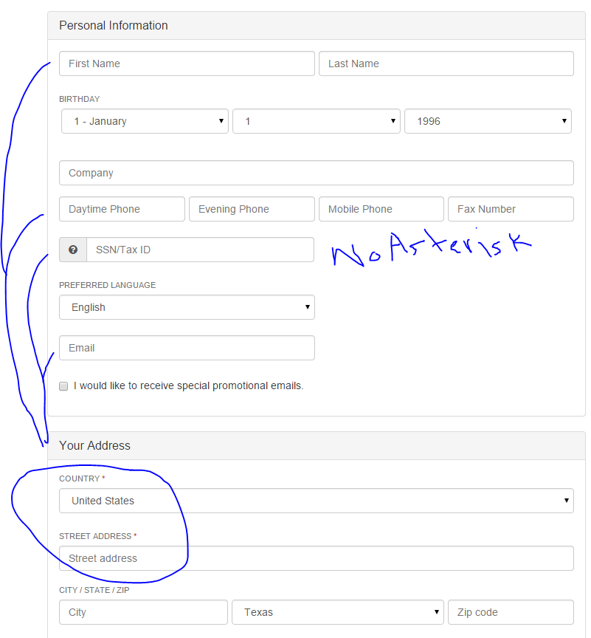

1. In the Sponsor Search Modal, if a user uses their middle button to scroll, the results scroll up ! The scrollbar and down arrow keys do scroll the correct direction however

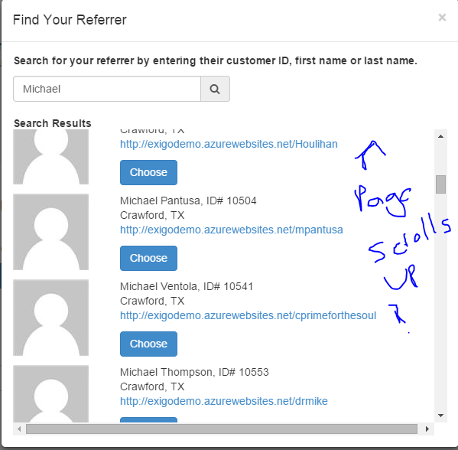

In addition, if you click on the “choose” button it does not return you to the enrollment options / configuration page. Rather, it tries to redirect to the azurewebsites link which does not exist for exigo demo

1. When you click the red “x” to remove the enrollment fee from the order summary on Shopping Items step, it is replaced with “Your cart contains no items” but no message with a context to direct them back to add a different enrollment. For the enrollment fee, perhaps the red x should be hidden or upon clicking it the customer is redirected back to the Packs step automatically

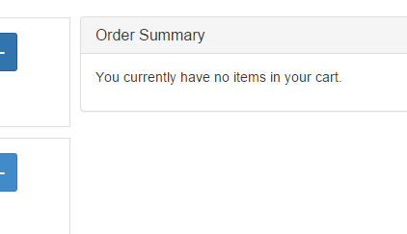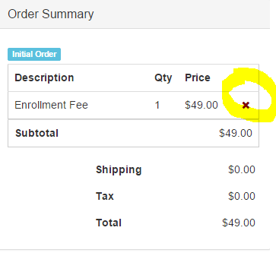A: Before removing: B. After:

Further, there needs to be validation message to tell them that they must add an Enrollment Kit – Perhaps displaying Enrollment Steps with check marks and x marks below the Order summary would be helpful?

1. 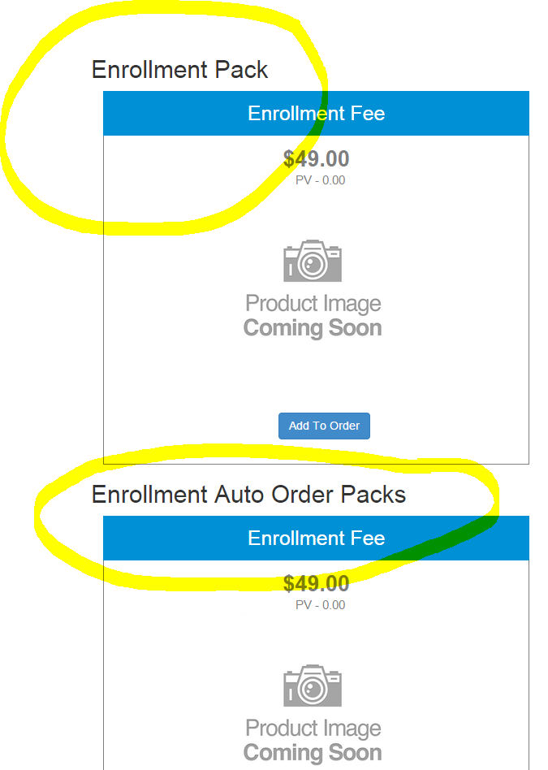Enrollment fees are typically one-time for distributors while they have to have an Auto Order for an Enrollment kit – Enrollment Kits should be added as demo packs – and PCs have to add the Enrollment fee as an annual fee, which is typically different from the distributor fee
2. Since the Preferred Customer is a Retail Customer with annual fee and autships…should we put their registration as an option / extra step under the Customer signup instead of under the Enrollment process? This way, like with Pangea, they are registered as a retail customer and then upgraded after they checkout with the payment for their fee and would remove any complications from having to hide form items not applicable to PCs – Tax ID, personal site, etc. We would just need to add the autoship manager option to their account on the Replicated site since they don’t have the distributor backoffice
3. Enrollee Info form – We need to make the block with Tax ID, Email, and Language line up better and more in line with how the rest of the form fields look:

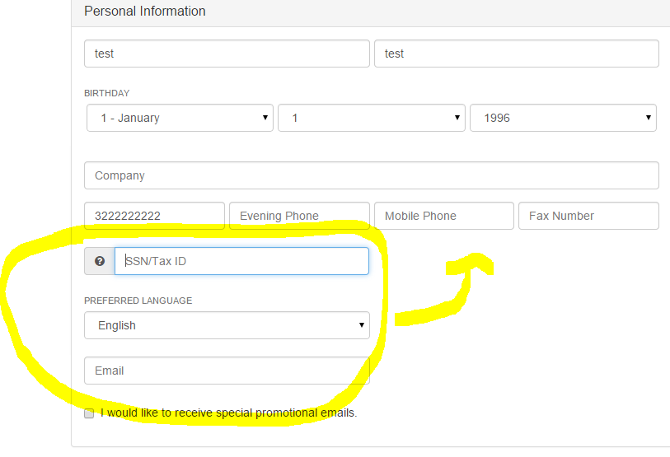

1. Need to remove the border on the address strength indicator bar to clean up the look of this form field

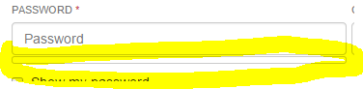

1. Not all of the fields are displaying the validation errors they should when left empty:

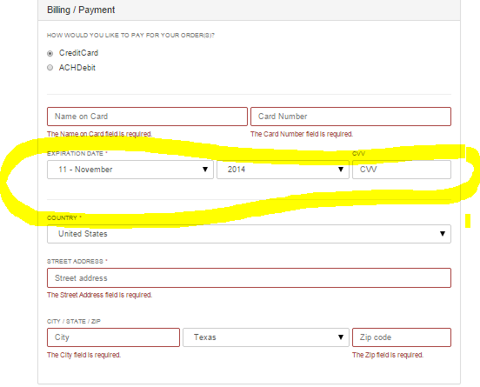

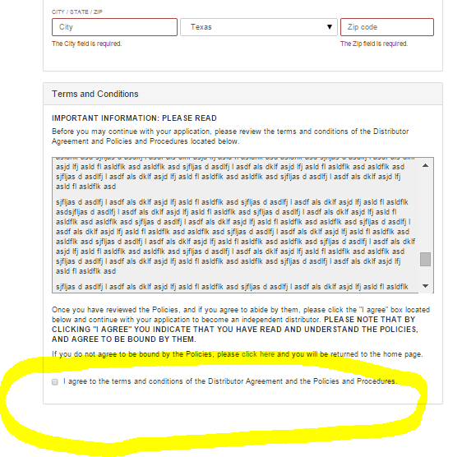

1. While the Enrollment Form would not submit if I didn’t check the box to agree to the terms, no validation error displayed. Again, a toastr validation message might be missing or not working
2. Enrollment Complete page needs to have a broken image removed:

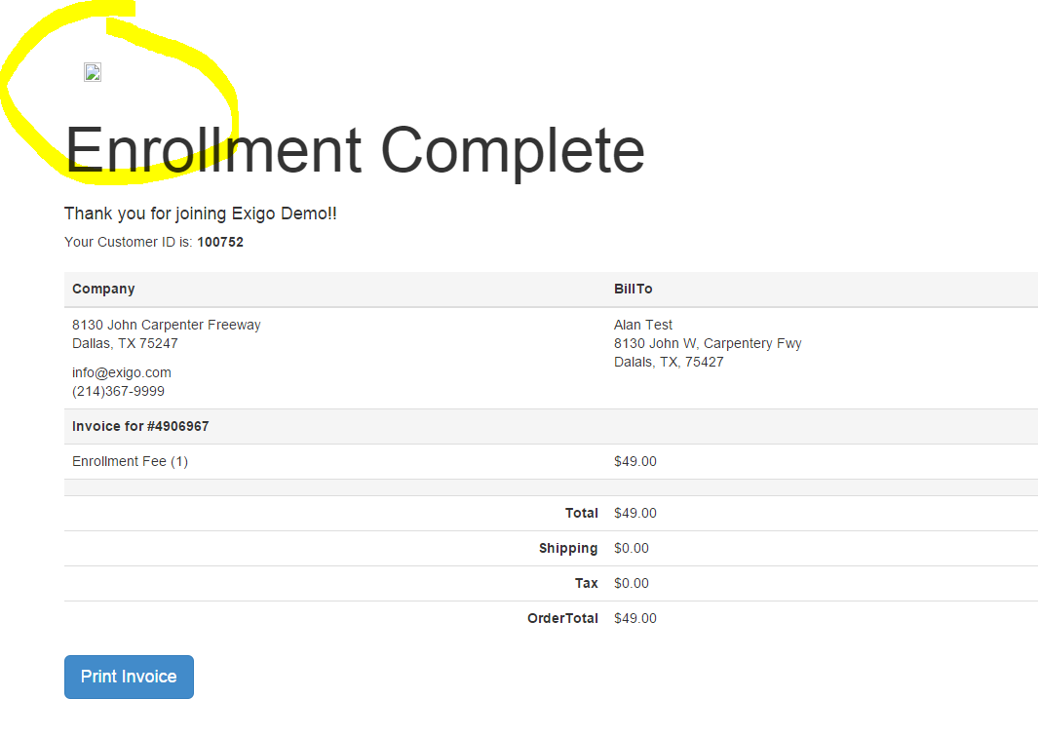

# Shopping

1. Product Category names need to be switched out – still showing names from Pangea – probably better to add these as reusable labels in a Resource File that can then be updated to fit the Client and “Category” is misspelled in the Header and the category navigation menu

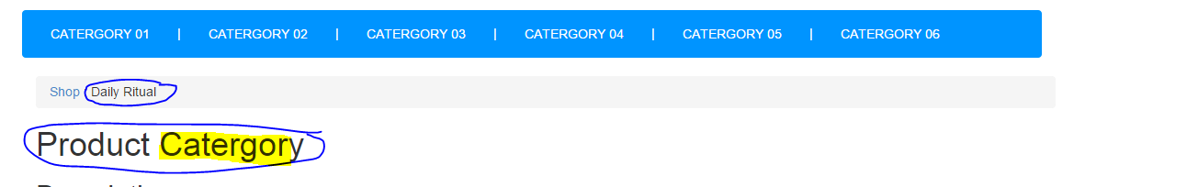

1. No products are displaying – code for the category pages may still be set to Pangea’s model – need to add back in the Single item cards to display Exigo demo products; also the headers sub-category menu needs to be updated to generic labels or removed – they are displaying Pangea specific names

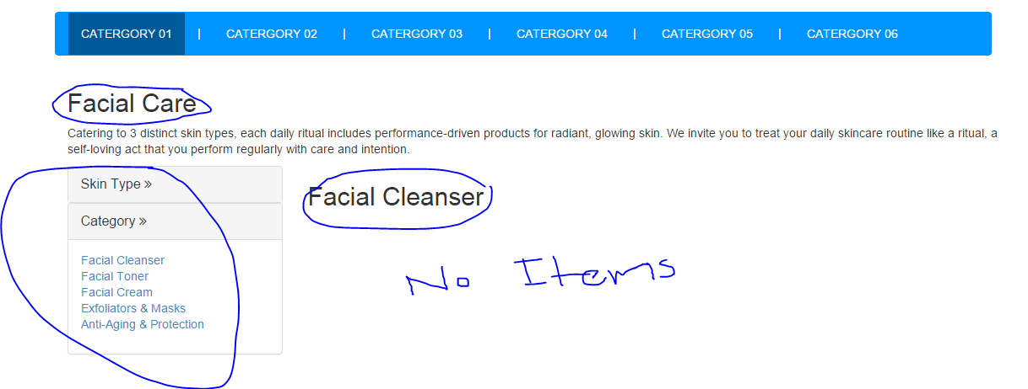

1. Cart returns error because it has code form Pangea not present in this project; error handling needs to be added for the cart view as well
2. Cannot test add item to cart functionality because there are no shopping items currently displaying
3. Broken Code needs to be removed from Default Shopping landing page

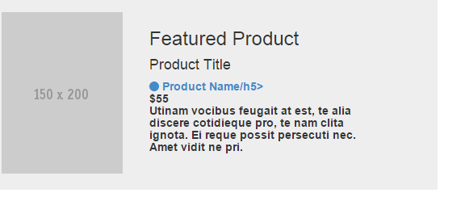

1. Products on the bottom of the Shop landing page could be made dynamic:

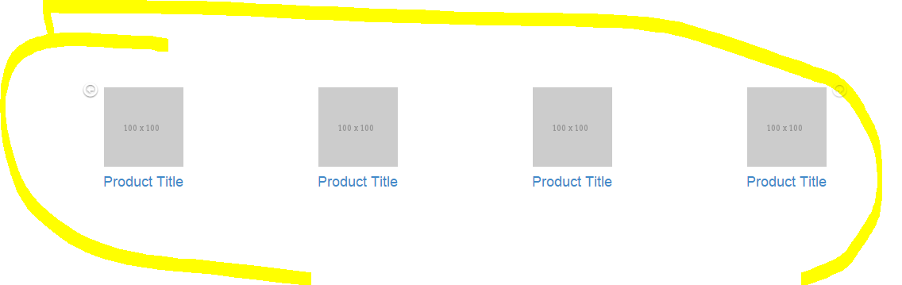

# Main / Default Layout

1. 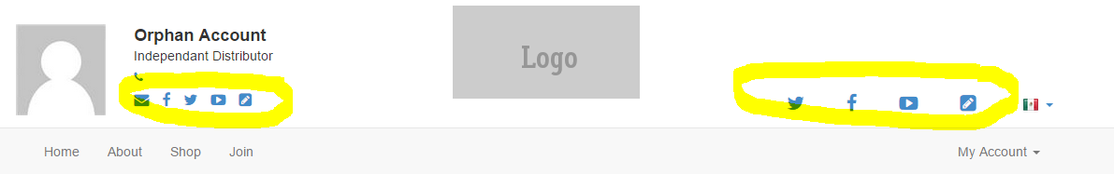The social media / blog links are either duplicated here or if the right side links are for the corporation, the “blog” link may need to be removed. These could be set to dynamically hide / show based on whether their values are null
2. Right side of header:
   1. 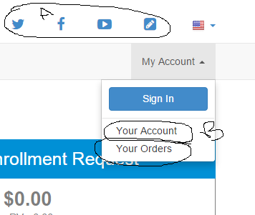YouTube link points to “youtube.net” – should a sample Exigo page be displayed for these instead of links to the websites? Another option is to add share functionality for these links instead
   2. “Orders” and ‘My Account” Links on the My Account dropdown menu needs to be moved under the options that display if the customer is logged in
3. 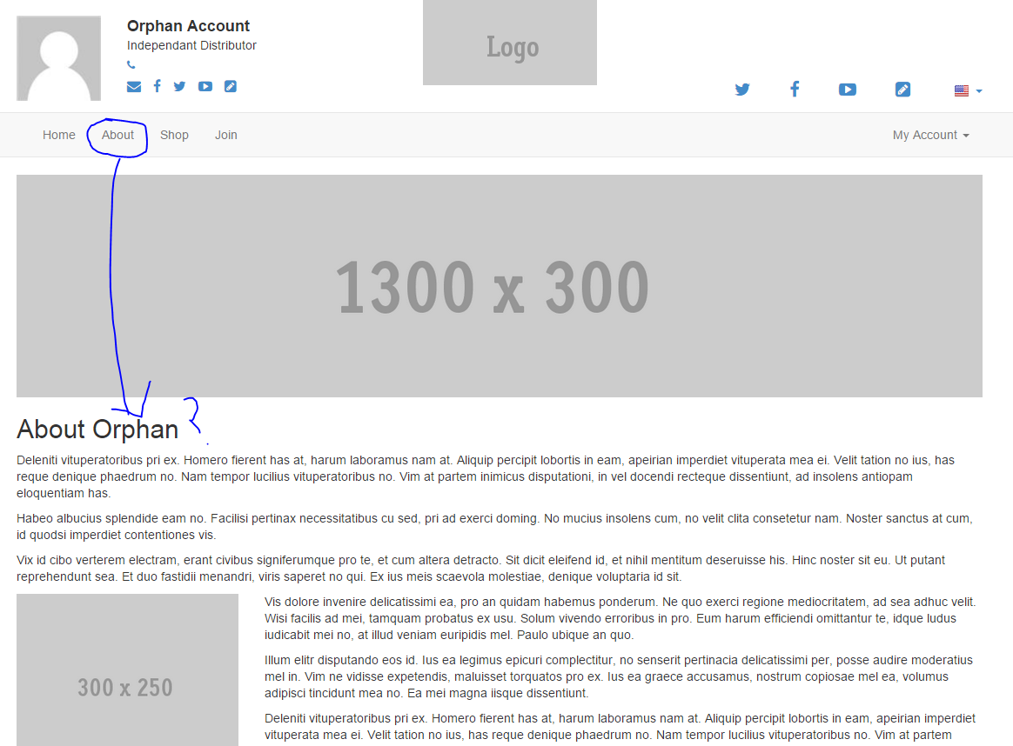Should the “About” Link on the main navigation be changed to link to a corporate About the company page? On Pangea we have a conditional statement that displays this if the current identity is null and if not null then displays the name of the distributor / owner and links to their site
4. The site is not correctly displaying the current webalias / updating the webalias for the site. I changed orphan out for another distributor and the site still displayed the orphan account webalias in the header above the main navigation menu. The orphan web alias still displayed even after I completed an enrollment
5. There is no option for “Customer Sign Up” on the default layout – only the Enrollment “Join” link for Distributors and Preferred Customers and the retail Customer registration is only accessible through the Cart and the Login page

An example of how to fix this is Origami Owl’s navigation options:

There is a “Join our Team” link that is for the distributor / pc equivalent registration form, while “Customer Sign up” takes them to the retail customer registration form

1. The header / main navigation has some problems when collapsed to mobile:
   1. In circle A – should the Orphan / site info be hidden or moved to below the main navigation?
   2. In circle B – the logo is broken because it’s still set to the Pangea logo – needs to be a placeholder

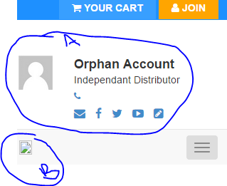

1. 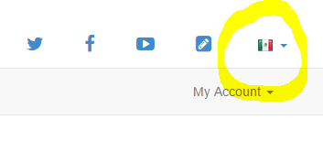Should we add in resource files for Spanish translations of demo content – to demonstrate that we support translating? Otherwise, selecting Spanish on the language dropdown does nothing
2. We could consider adding a footer navigation feature to the framework that contains placeholder pages for Privacy policy, Terms of Use, Email Subscription sign up, Info on becoming a distributor and such since these are often added in by many of our clients

# Account

1. Image from Pangea Customer registration form needs to be removed / replaced

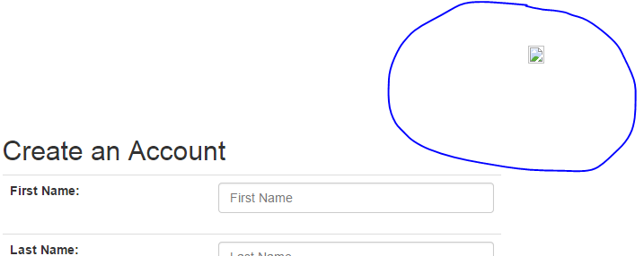

1. The password validation and password strength functions from the distributor / pc enrollment form might be nice to add to the retail customer registration form.

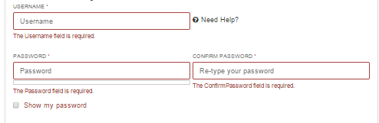

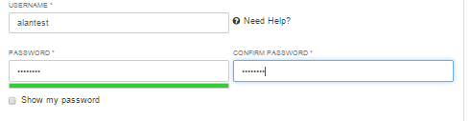

1. Also, either a label or a checkbox for agreeing to site usage terms and conditions and privacy policy, which are sometimes required for the retail customers, might be a good thing to add to the retail customer form

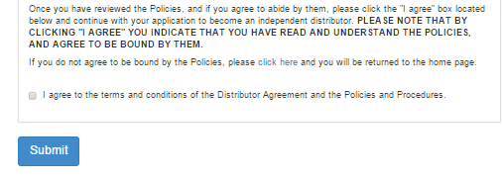

If validating this for retail customers is not necessary, we could add in a demo statement that states ‘By registering as a customer, you are agreeing to our Terms of Use and Privacy Policy” with a link or pop up for them to ready the policies

1. The breadcrumb feature in the Account is not working – it should display the current page and the Home icon should link back to the main account page

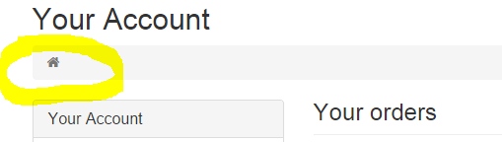

1. The Address editor form in the Account section is missing its Anti-Forgery validation token and fails
2. Credit Card editor / add new credit card form: Google brings up previous form data for the credit card number – should we block this functionality as a security measure?
3. Add Credit Card and Add Bank Account forms fail to submit and return he same error as Address editor as the Anti-Forgery token is missing

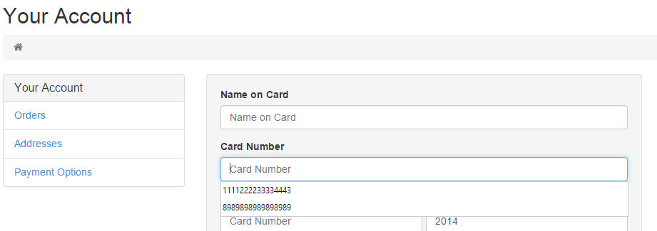

1. Expiration date editor is targeting the Credit Card number editor field instead of the date editor

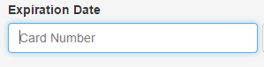

1. I tried to edit the language field in the Account Settings editor and it required me to change my password in order to proceed; also context is unclear as it simply highlights the field and no validation message / toastr error is displayed. Same error occurs if you click any of the “Save Changes” buttons –

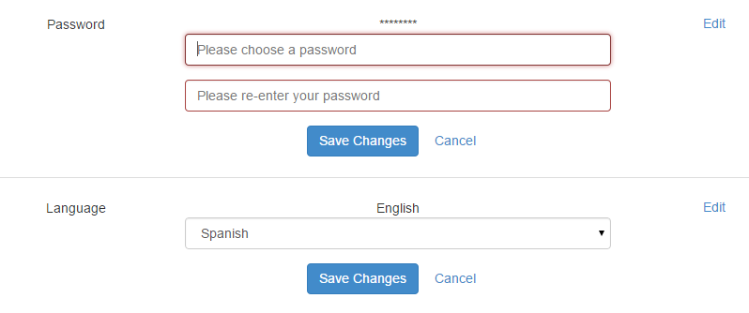

1. The “Edit” button in each box of the Account overview does not work. Perhaps the “Save changes” button should be removed or the editor form hidden until the edit button is clicked or maybe the Edit button should then take the customer to a separate page / modal to edit the respective fields